**Amazon Connect CCP**

**Integration with Enghouse Interactive Vidyo.IO**

Version 1.0.0.0-Beta

Terms of Use

Any software (“Software”) that is made available by Enghouse Interactive Inc. (“Enghouse”), together with any User Documentation (“User Documentation”) is the copyrighted work of Enghouse. Use of the Software is governed by the terms of a Master Purchase Agreement, End User License Agreement, or similar software license agreement ("License Agreement"). End users are not legally authorized to install any Software that is accompanied by or includes a License Agreement unless he or she first agrees to the License Agreement terms.

The Software is made available for installation solely for use by users according to the License Agreement. Any reproduction or redistribution of the Software not in accordance with the License Agreement is expressly prohibited by law and may result in severe civil and criminal penalties. Violators will be prosecuted to the maximum extent possible.

WITHOUT LIMITING THE FOREGOING, COPYING OR REPRODUCTION OF THE SOFTWARE TO ANY OTHER SERVER OR LOCATION FOR FURTHER REPRODUCTION OR REDISTRIBUTION IS EXPRESSLY PROHIBITED, UNLESS SUCH REPRODUCTION OR REDISTRIBUTION IS EXPRESSLY PERMITTED BY THE LICENSE AGREEMENT ACCOMPANYING SUCH SOFTWARE.

THE SOFTWARE IS WARRANTED, IF AT ALL, ONLY ACCORDING TO THE TERMS OF THE LICENSE AGREEMENT. ENGHOUSE HEREBY DISCLAIMS ALL OTHER NON-EXPRESS WARRANTIES AND CONDITIONS WITH REGARD TO THE SOFTWARE, INCLUDING ALL IMPLIED WARRANTIES AND CONDITIONS OF MERCHANTABILITY, FITNESS FOR A PARTICULAR PURPOSE, TITLE, AND NON-INFRINGEMENT.

Enghouse grants a nonexclusive license to customer for use of the User Documentation. The User Documentation contains copyrighted and other proprietary materials. By accepting the User Documentation, recipients agree that they will not transmit, reproduce, or make available to any external third-party this User Documentation or any information contained herein. Copying, reverse-engineering, or reselling any part of the Software or User Documentation is strictly prohibited.

The information contained in the User Documentation furnished by Enghouse is based on the most accurate information available at the time of printing. No representation or warranty is made by Enghouse as to the accuracy or completeness of such information or any ongoing obligation to update such information. Enghouse reserves the right to change the information contained in this document without notice.

Registered Trademarks

Syntellect®, Voiyager®, Continuum ®, MediaVoice®, Apropos®, Envox®, Envox® Activecall, Envox CT ADE®, Envox CT Connect®, Dynamic Application Discovery®, Interaction Vault® CT Impact®, SmartDialer®, SmartVoice®, SmartCollect®, SmartSupport®, Zeacom®

Software User License Agreement

Enghouse Interactive Inc., for itself, subsidiaries, affiliates (“Licensor”), or by and through its authorized resellers offers You use of this product (“Software”) expressly contingent upon Your agreement to all terms and conditions in this license agreement, acceptance of which You affirmatively signify by clicking “I accept” below or alternatively by installing, copying or otherwise using the Software, you agree to be bound by the terms of this agreement. If You do not agree to all of the terms contained herein, click “I decline” and/or return the Software to Licensor immediately upon rejection, without installing, copying, or using the Software for a refund thereof. Your use of the Software, even if obtained in contravention of this license agreement or obtained otherwise than through Licensor or its authorized resellers, indicates Your agreement to all of these terms. If you install the Software on behalf of a party, you must ensure that they are provided with and agree to the terms of this License Agreement prior to installation.

1. Definitions. “You” and “Your” refer to each entity using the Software, regardless of payment of any license fee to Licensor for the Software, but do not include affiliates, subsidiaries, parents, consultants, or any other third party, absent Licensor’s express written consent. “Software” includes any updates, upgrades, enhancements and modifications. You may receive from Licensor via purchased maintenance and support services. "Intellectual Property Rights" means any and all rights existing from time to time under patent, copyright, trade secret, trademark, or unfair competition law, and any and all other proprietary rights, and any and all applications, renewals, extensions and restorations thereof, now or hereafter in force and effect worldwide.
2. License.
   1. Evaluation License. If You have obtained the Software for evaluation purposes and/or have not paid Licensor or its authorized reseller the applicable license fees for the Software, Licensor grants You a nonexclusive, nontransferable, limited, personal license for 30 days (unless otherwise expressly stated to You in writing by Licensor) (“Evaluation Period”) to use the Software, in accordance with its documentation, solely for the purpose of evaluating the Software for Your internal business purposes and solely on one (1) computer server at one (1) physical site owned and/or controlled by You. You may not use the Software for production purposes and all Software and documentation must be returned to Licensor at the end of the Evaluation Period.
   2. Internal Use License. Subject to Your payment of the applicable license fees to Licensor or its authorized distributor, Licensor grants You a nonexclusive, nontransferable, limited, personal license to use the Software, in accordance with its documentation, solely for Your internal business purposes, limited to the site(s), number of seats, users, agents, servers, ports, devices, managed applications, and/or copies for which You have paid the applicable license fees as is expressly designated on valid Purchase Orders in aggregate as applicable to the Software obtained. If you need to increase the number of resources that are simultaneously executed or executable, you must contact Licensor or their authorized reseller to obtain authorization that enables the larger number of resources. No duplicate or copied instances of seats, users, agents, servers, ports, devices, managed applications, and or copies are allowed without having purchased such usage from Licensor or its authorized resellers.
3. Restrictions. You shall not, without express permission to the contrary by Licensor (i) process the data of any other party or use the Software in a service bureau or timeshare manner, (ii) sell, publish, disclose, display, or otherwise make available the Software or copies thereof to, or permit the use thereof by, others not specifically authorized hereunder, (iii) transfer or assign in any manner, in whole or in part, rent, lease, or trade-in the Software or any copy thereof, any attempt of which shall be void, or (iv) allow access to the Software outside the permitted site(s). You may make one copy of the Software for archival or backup purposes and copies of Licensor’s non-training documentation as necessary, provided that such copy(ies) shall include Licensor's copyright and other proprietary notices. Otherwise, You may not copy or print, in whole or in part, the Software or documentation. All copies thereof remain the exclusive property of Licensor. You shall not, nor permit anyone to, de-compile, disassemble, reverse engineer, or in any manner otherwise attempt to learn the inner workings or derive the source code of the Software. The Software is proprietary to Licensor or its licensor, and title to it remains in Licensor or its licensors. The Software is protected by trade secret and copyright law and international copyright treaty, and may be the subject of United States patents and patents of other jurisdictions. All applicable Intellectual Property rights, including copyrights, trade secrets, patents, and trademarks in the Software and documentation, or any modifications or enhancements thereto, shall remain with Licensor.
4. Confidentiality. The Software and its documentation contain confidential information of Licensor. You agree to use at least a reasonable degree of care to prevent disclosure of such information to third parties, absent Licensor’s express written consent to such disclosure.
5. Termination. You may terminate this license immediately by destroying all copies of the Software in Your possession. This license will terminate automatically, without notice from Licensor, immediately (i) upon the breach of any terms of this license, or (ii) in the event You file for bankruptcy protection, are declared bankrupt in any jurisdiction, or have a receiver appointed, and such filing, declaration, or appointment is not rescinded within ninety (90) days.
6. Maintenance. Maintenance and support for the Software are not provided under this license but may be purchased separately from Licensor or its authorized resellers subject to Licensor’s then-existing standard maintenance terms.
7. Warranty. Licensor warrants that, for a period of sixty (60) days following the date of shipment, the media on which the Software is delivered to You, if any, will be free from defect in materials and workmanship. Licensor’s sole liability, and Your sole remedy, for a breach of the foregoing will be the replacement of such media. EXCEPT FOR THE FOREGOING AND TO THE EXTENT PERMITTED BY LAW, LICENSOR SPECIFICALLY HEREBY DISCLAIMS ALL OTHER WARRANTIES, EXPRESS OR IMPLIED, INCLUDING, WITHOUT LIMITATION, THE IMPLIED WARRANTIES OF MERCHANTABILITY, FITNESS FOR A PARTICULAR PURPOSE, AND ANY WARRANTY AGAINST INFRINGEMENT OF ANY INTELLECTUAL PROPERTY RIGHT OF ANY THIRD PARTY.
8. Liability. TO THE EXTENT PERMITTED BY LAW, LICENSOR SHALL HAVE NO LIABILITY UNDER THIS LICENSE FOR INDIRECT, SPECIAL, CONSEQUENTIAL, EXEMPLARY, INCIDENTAL, OR PUNITIVE DAMAGES (INCLUDING, BUT NOT LIMITED TO, DAMAGES FOR LOSS OF BUSINESS PROFITS, BUSINESS INTERRUPTION, LOSS OF USE, LOSS OF BUSINESS INFORMATION, OR OTHER DATA, OR ANY OTHER PECUNIARY LOSS), EVEN IF ADVISED OF THE POSSIBILITY OF SUCH DAMAGES, AND IN NO EVENT SHALL LICENSOR'S LIABILITY FOR ANY CLAIM ARISING OUT OF THIS AGREEMENT (BE IT CONTRACT, NEGLIGENCE, AND STRICT LIABILITY IN TORT OR WARRANTY) EXCEED THE AMOUNT PAID TO LICENSOR BY YOU FOR THE SOFTWARE. THIS LIMITATION SHALL BE ENFORCED EVEN IF DOING SO CAUSES ANY REMEDY TO FAIL OF ITS ESSENTIAL PURPOSE. NO CLAIM MAY BE BROUGHT BY YOU UNDER THIS AGREEMENT MORE THAN ONE (1) YEAR AFTER ACCRUAL OF SUCH CLAIM.
9. Miscellaneous.
   1. Governing Law. This license and performance hereunder shall be governed by the laws of the United Kingdom of Great Britain and the sole jurisdiction for any legal proceedings under this license shall be in jurisdiction of English Courts.
   2. Export Compliance. At Your own expense, US export/import law and regulations with respect to the Software and shall not export/import the Software in violation thereof. You are liable for any taxes, fees, or assessments arising out of Your use of the Software.
   3. Government Use. All Software Licenses and documentation furnished pursuant to this Agreement were developed at private expense and are provided with RESTRICTED RIGHTS. Any use, duplication or disclosure by or for a governmental entity or agency shall be subject to the restricted rights applicable to commercial computer software.
   4. Severance. If any provision of this license is deemed invalid, illegal, or unenforceable under any applicable statute or rule of law, it is deemed modified to the degree necessary to comply with applicable law, and the remaining provisions shall remain in force and unaffected.
   5. Injunction. You agree that Your breach of any provision of this license will cause Licensor irreparable injury that is inadequately compensable in monetary damages and, accordingly, that Licensor shall be entitled to injunctive relief in any court of competent jurisdiction against the breach or threatened breach of this license, in addition to any other remedies in law or equity.
   6. Waiver. The waiver or failure of Licensor to exercise in any respect any right provided for herein shall not be deemed a waiver of any further right hereunder and no waiver shall be effective unless in writing.
   7. Assignment. You agree that this license is nontransferable, even as part of the sale of any portion of Your business, or pursuant to any merger, consolidation, or reorganization, without Licensor's prior written consent, but that Licensor may assign freely any of its rights or obligations under this license.
   8. Entire Agreement. This license constitutes the entire agreement and understanding between You and Licensor, supersedes any prior agreement or understanding whether oral or written, relating to the subject matter hereof, and may be modified only by a written agreement signed by both parties. IF YOU HAVE A WRITTEN MASTER AGREEMENT WITH LICENSOR GOVERNING THE LICENSE AND USE OF SOFTWARE, SUCH MASTER AGREEMENT WILL CONTROL AND PREVAIL OVER THE TERMS OF THIS LICENSE.

Contents

Software User License Agreement 3

About This Document 6

1. Overview 7

2. System Requirements 8

System Requirements 8

Browser Requirements 8

3. Provisioning flow 9

4. Agent Application 10

Overview 10

Agent Deployment 10

5. Client Chat Application 12

Overview 12

Client Chat Deployment 12

6. Expected Functionality and Test Scenarios 13

7. Troubleshooting 17

# About This Document

## Audience

This document is intended for CCP administrators to assist in the deployment and or to customize CCP with Enghouse Interactive Vidyo.IO (Vidyo)

## Document conventions

This document uses the following text formats and notation conventions.

### Text format

Bold text indicates a button, field, link, option name, or similar function requiring an action.

Italicized text indicates new terms, directory paths, or references to external documents.

Text in this font indicates code.

### Notes and cautions

Icons used throughout this document identify additional details or special conditions.

|  |  |
| --- | --- |
| Symbol Information.gif | Note  Provides additional information or describes special circumstances. |

|  |  |
| --- | --- |
| Symbol Error.gif | Caution  Warns of user actions that may cause system failure or irreversible conditions. |

|  |  |
| --- | --- |
| Symbol Stop.gif | Stop  Describes actions that you should only perform under the supervision of Enghouse Customer Support. |

## Document feedback

To submit comments or questions regarding the content in this document, email  
[DocFeedback-CCSP@enghouse.com](mailto:DocFeedback-CCSP@enghouse.com).

## Contact information

For more information regarding Enghouse products, services, and support, please visit [www.enghouse.com](http://www.enghouse.com).

# Overview

The solution is based on the native AWS Streams API to integrate the Amazon Connect CCP agent with Enghouse VidyoPlatform.

The solution supports one on one personal video ‘conversations’ between a caller and CCP agent. The solutions supports escalation of chat calls to video.

The diagram below describes component architecture with customization on the agent and client side:

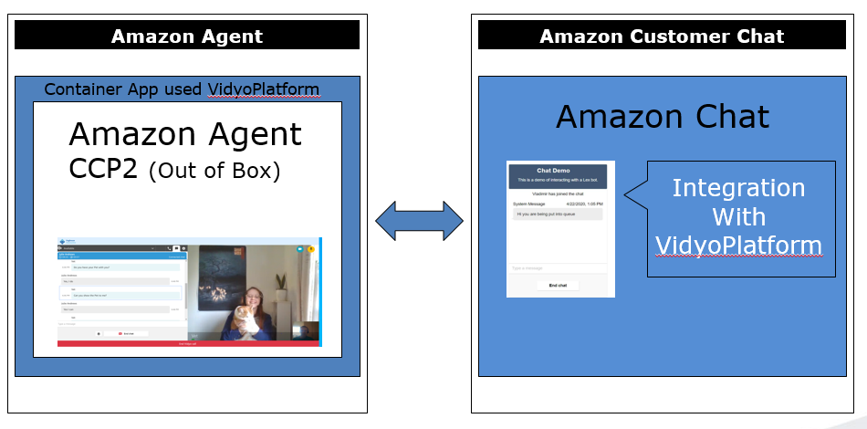

# System Requirements

## System Requirements

1. An active AWS account .
2. An Amazon Connect instance that has been configured to accept inbound chat calls.

## Browser Requirements

Vidyo is compatible with modern browsers supporting Amazon CCP and VidyoPlatform

Note:

<https://support.vidyo.io/hc/en-us/articles/115003251788-Supported-Browsers>

# Provisioning flow

* 1. After subscribing to AmazonConnect VidyoConnector from AWS Marketplace customer will receive registration email and should reply back with fallowing details:

your AmazonConnect **Instance ID**. This can be found at https://aws.amazon.com/premiumsupport/knowledge-center/find-connect-

instance-id/

* 1. We will inform you when your Vidyo tenant will be provisioned with **vidyoPlatformTenant** name and **tokenAgentPassword**.
  2. Download Enghouse connector code from <https://github.com/Enghouse-CCSP-PS/AWSConnectWithVidyo>
  3. Proceed to paragraph 4:Agent Application

# Agent Application

## Overview

The Agent side application is built on top of the CCP wrapper sample app and integrated with VidyoPlatform Code. The solution uses a Vue.js instance and additional helper JS libraries.

## Agent Deployment

1. Please follow the instructions at <https://aws.amazon.com/blogs/contact-center/perform-an-external-screen-pop-with-amazon-connect/>

Perform all the steps until ‘Import the Contact Flow and Assign it to a Phone Number’ is reached

1. You will require the latest sources for Amazon Connect API libraries available from:
   1. <https://raw.githubusercontent.com/amazon-connect/amazon-connect-chatjs/master/dist/amazon-connect-chat.js>
   2. <https://raw.githubusercontent.com/amazon-connect/amazon-connect-streams/master/release/connect-streams-min.js>
      * Update the .js files inside folder accordingly to latest versions.
2. Upload the ‘ccp-v2_agent/VidyoContainer.html’ file to an existing S3 bucket created in step #1 and make it publicly accessible.
3. Upload the ‘ccp-v2_agent/VidyoContainerScript.js’ file to an existing S3 bucket created in step #1 and make it publicly accessible.

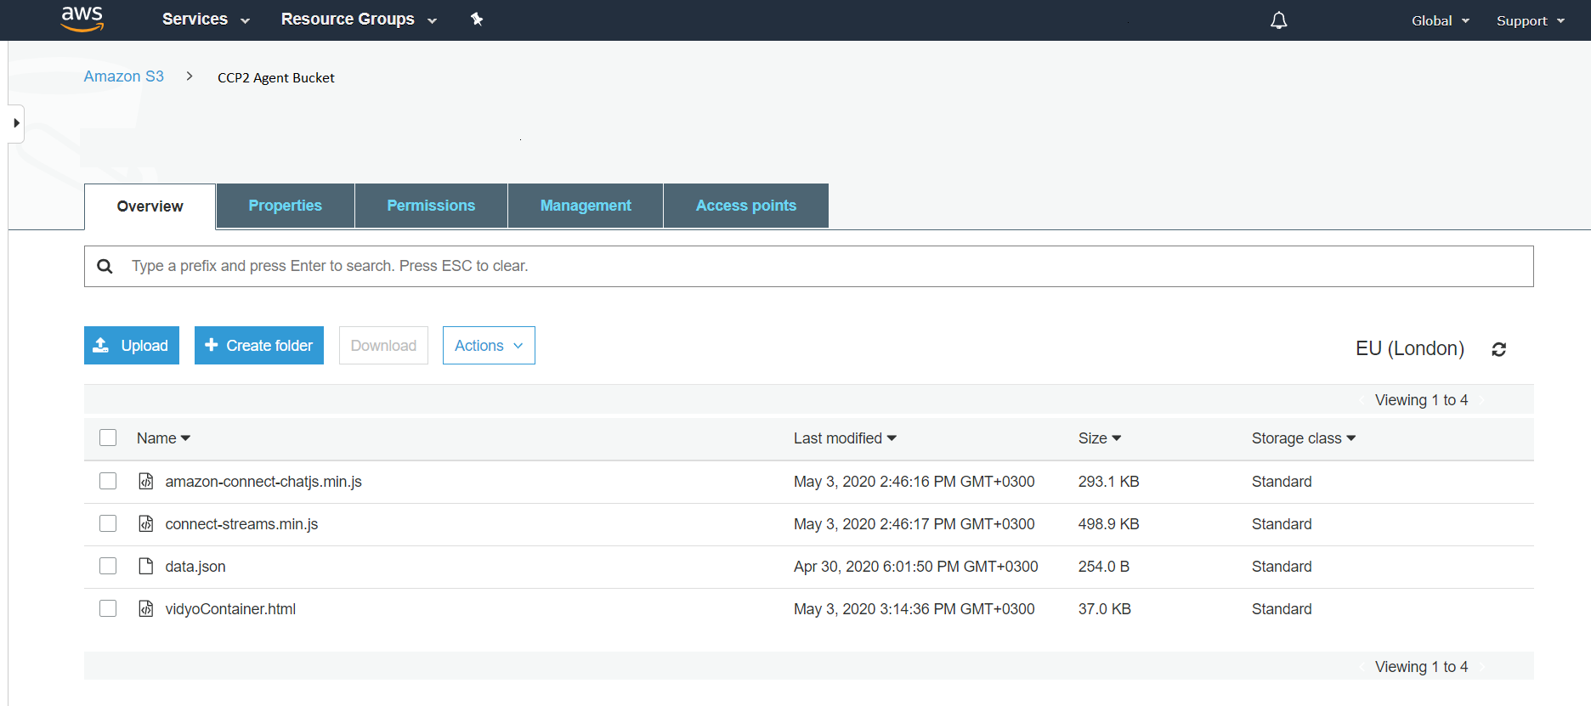

1. Update **data.json** parameters with your Vidyo instance details.

The parameters are:

* + " **vidyoApiUrlPrefix**": This is your service API required to obtain the Vidyo token. Use default
  + "**vidyoPlatformTenant**": You will receive it from Enghouse Interactive
  + "**instanceName**": Your Amazon Connect instance name
  + "**tokenAgentPassword**":  You will receive it from Enghouse Interactive
  + "**timeoutForDisconnectVidyoMS**": Timeout for connect vidyo. (Default: 60000MS = 1Minute).

If after this time the video call did not connect properly, the video call will disconnect.

# Client Chat Application

## Overview

Customer side chat is based on ‘Amazon Connect asyncCustomerChatUX’ sample demo

This has been integrated with Vidyo.io and some helper JS libraries.

## Client Chat Deployment

1. Follow the instructions from the link below and provision all steps by deploying CloudFormation stack:

<https://github.com/amazon-connect/amazon-connect-chat-ui-examples/tree/master/cloudformationTemplates/asyncCustomerChatUX/website>

1. Replace "index.html" in created the AWS S3 bucket from step#1 with Enghouse "ccp-v2_client/index.html" and make it publicly accessible:

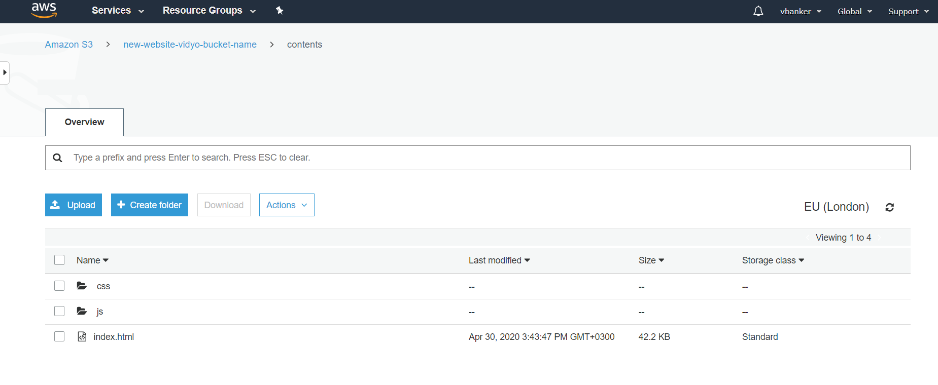

# Expected Functionality and Test Scenarios

1. **Basic Chat Flow Scenario**
   1. Navigate to the URL of the S3 bucket and fill in basic details which will start a client/customer chat session

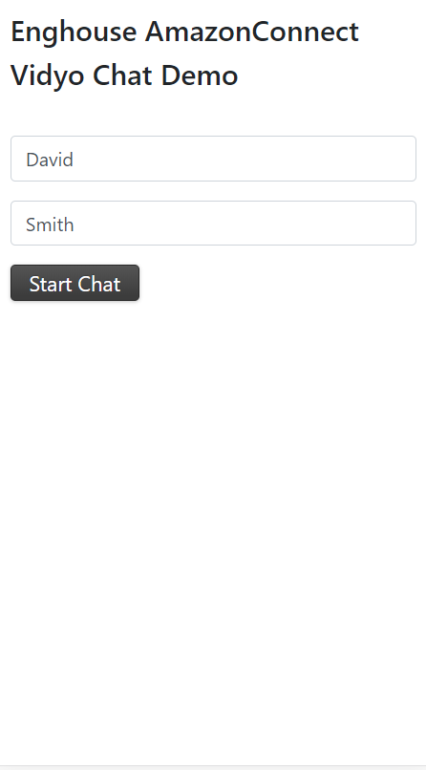

* 1. Accept the resultant incoming chat call in the CCP agent:

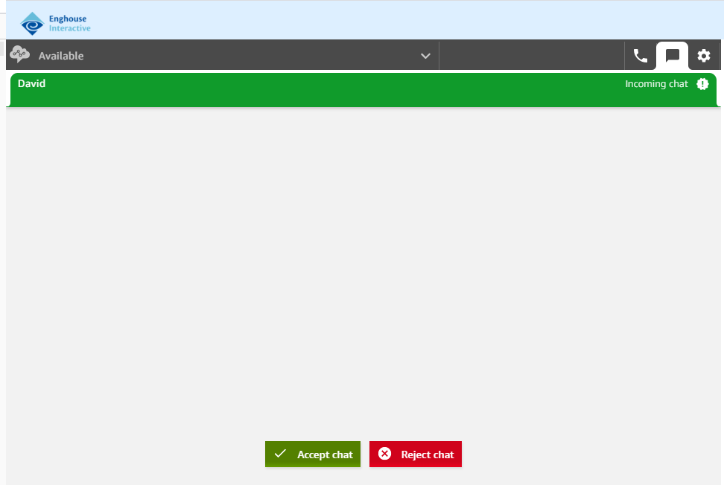

Expected result: A chat session is now active between both parties

Example Screen Shot

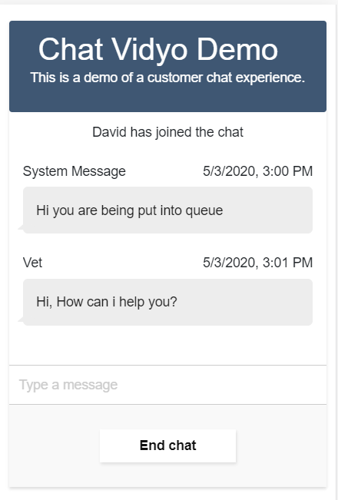

1. **Video Scenario:**
   1. Once a chat session has been established, Agent should click the ‘Start Vidyo Call’ button.
   2. If there is more than one customer, you will see a drop down list with active chat sessions.
   3. Select one of the participants and press ‘ok’.

Example Screen Shot

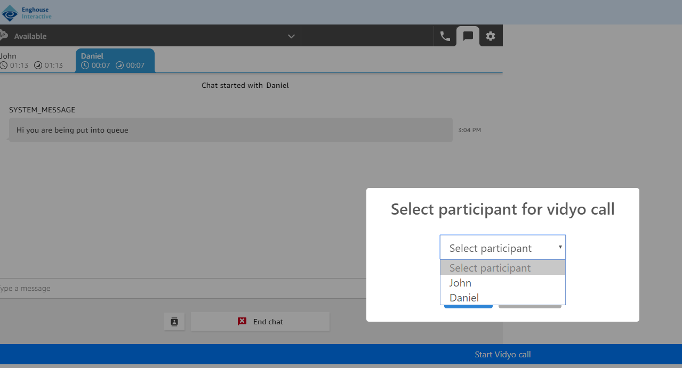

* 1. The caller chat will see this example (or TinyURL equivalent)

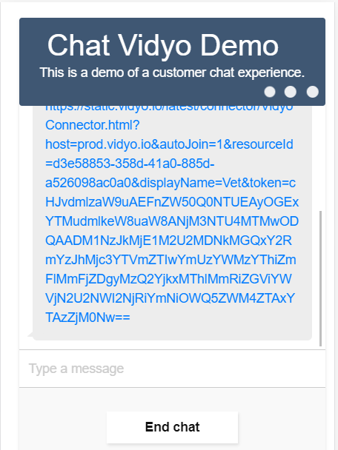

* 1. Both parties should now see active real-time video taking place

Example Screen Shot

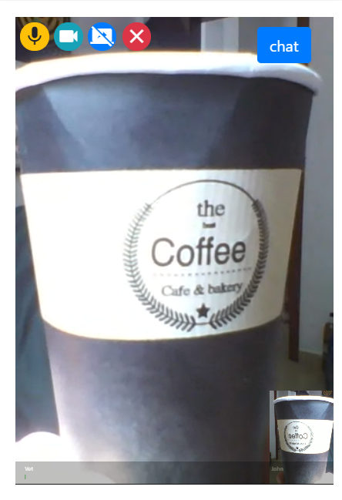

Example Screen Shot

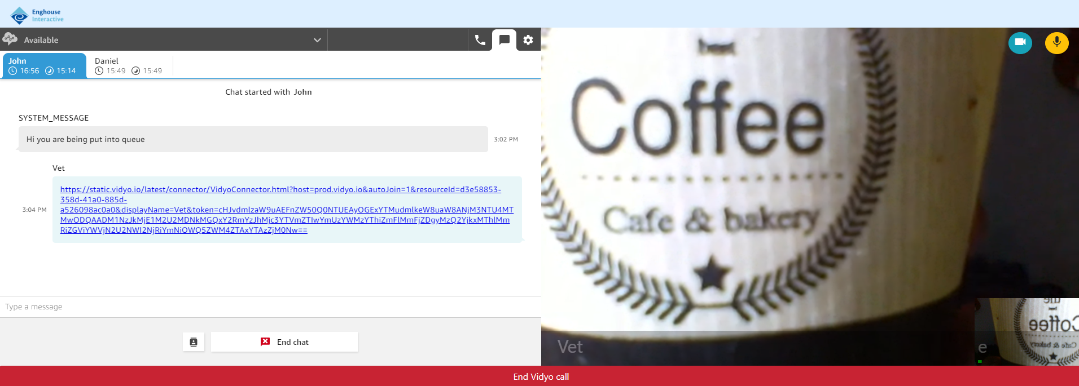

1. **Mute/Unmute Scenario:**

In this test, Mute and Unmute the Camera and Microphone by clicking on the buttons provided:

**Customer Side**



**Agent side**



1. **Call screen share scenario:**

Start the video call, then click on the Share Screen icon.

Expected result: Screen share will start.

1. **Disconnect Video session scenario:**

Disconnect the video call at the agent side or using the (X) button at the customer side. Or select ‘end chat on the customer side

Expected result - The video session is closed

**This concludes basic operational test scenarios**

# Troubleshooting & FAQ

**FAQ:**

* When I click on "start video" it's not start
  + First, press F12 and see what is the error. Possible reasons:
  + Incorrect parameters:

Check that the parameters on data.json are correct. (vidyoApiUrlPrefix, vidyoPlatformTenant, instanceName, tokenAgentPassword)

* + API problem:

See if you get related error. (e.g. "Service unavailable" or other API error).

Check the license and see if it is valid.

* When video started black screen appears on camera view.
  + Try to switch camera – if succeeded – check the camera settings.
  + Check the permission for devices.
* When I click on "start video" it's not start immediately (It take a long time)
  + Check your Internet connection speed.

**END OF DOCUMENT**